

Table of Contents

Introduction 4

Aim 5

Objective 5

Justification 6

Problem statement 6

Solution 7

Researched Question 8

Literature Review 8

Secondary Research 8

Development Methodology 10

Waterfall 10

Tools 11

Technology 11

Integration 12

Risk Analysis 13

SWOT Analysis 14

Conclusion 15

Reference 16

Figures

Figure 1: Overview of ridesharing 4

Figure 2: Objective of research 5

Figure 3: People facing problem in public transportation 6

Figure 4: Problem solution 7

Figure 5: Stages in waterfall methodology 10

Figure 6: Integrations of tools and technology 12

Figure 7: SWOT analysis of ridesharing app 14

# Introduction

Transportation management is one of the main problem at the moment. As the world’s population is growing rapidly, it bring up the topic of social and public issues. Public transportation is the key challenge that may hamper the citizen, business, others stakeholders of the nation. As we live in 21st century, People manage their busy lives and communicate with each other around the world with the help of communication technologies like mobile devices and GPS which stands for Global Positioning system. Smartphones are essential because the proliferation of apps has had a significant impact on the creation of new enterprises. People use this platform to request rides and communicate with one another in the ride-sharing industry.

In this project “Ridesharing app” there are two types of users: - driver and customer. Driver can register and login, the data are synchronized in firebase real time database. Customer can login and request for ride. The system suggests near driver available as soon after the customer request for ride. The system calculates the distance between user’s location and destination and calculates the total cost for the ride. After the ride is completed, the user and rider can rate and review each other between 1 to 5 stars. As soon as the rider completes the rides, they can accept another ride and similarly completes the process. The users can check their ride history and send feedback. The app supports route planning, searching for location in convenient way. The location of driver and passenger is continuously tracked in a real time with the help of Google Map.

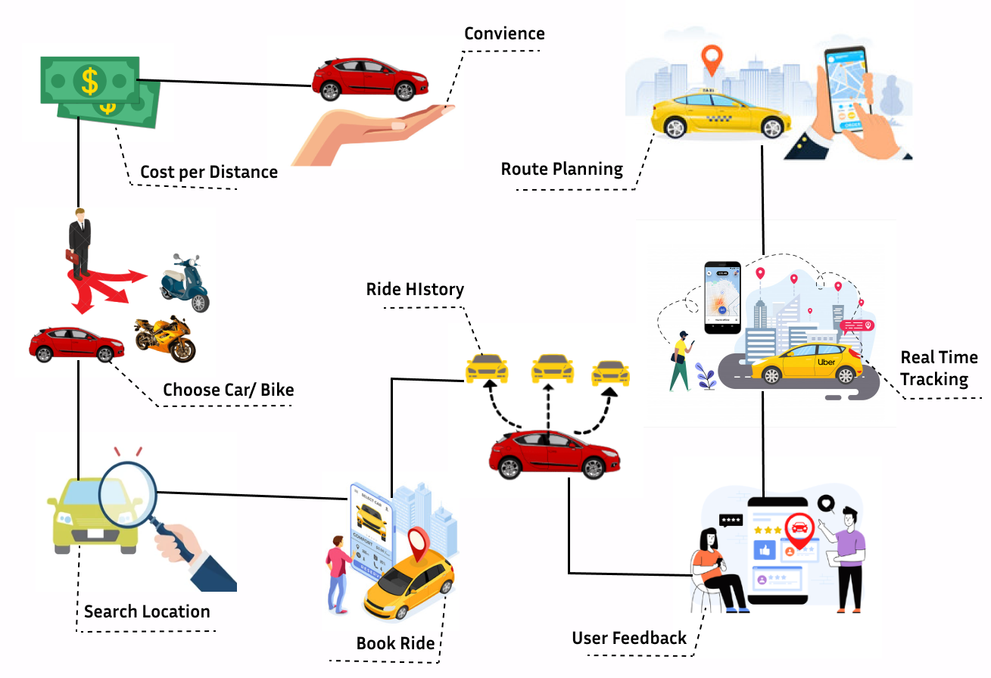

Figure 1: Overview of ridesharing

# Aim

Evaluate the potential benefits of integrating GIS in ridesharing and to identify the techniques that enhance the usability of the system.

# Objective

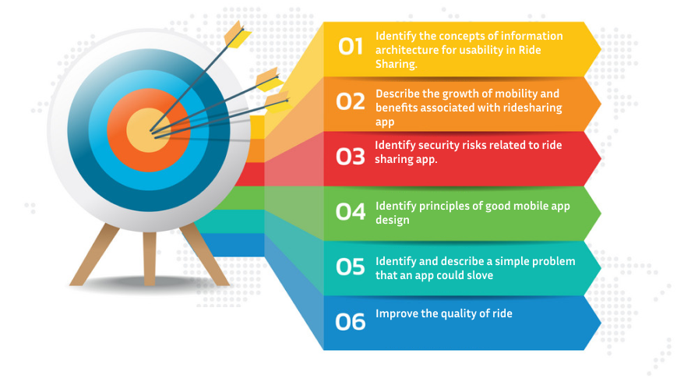

Figure 2: Objective of research

# Justification

## Problem statement

Transportation is the major issues around city areas. If you don’t own a personal vehicle it’s really hard to move around the city during peak hour. The individuals have to struggle a lot to move to their destination. Due to traffic congestion and overpopulation the people have to wait a lot for the public transport. So, people have to face lots of problem related to time. The individuals of the country are facing mobility problems. Safety is also one of the major public concern to focus on while using public transportation. Individuals have to suffer from different criminal activities like harassment, pickpocketing etc.

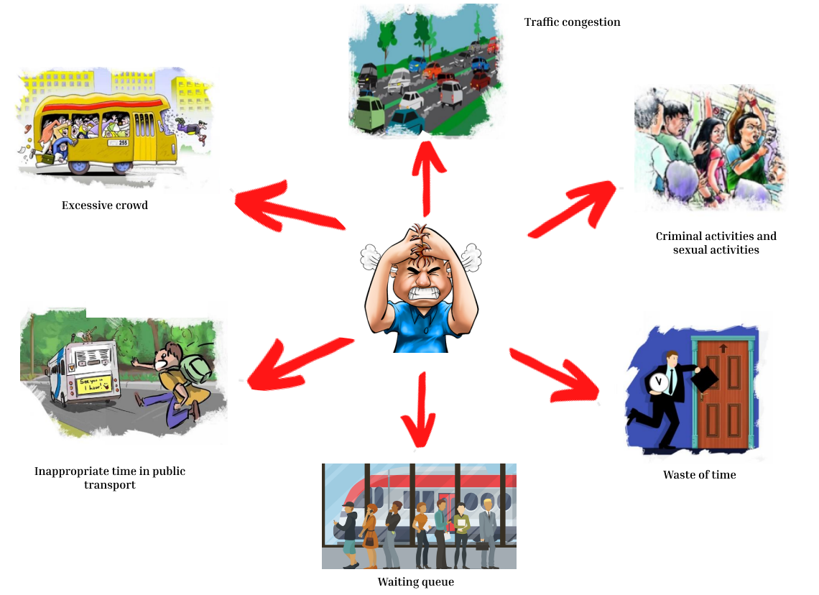

Figure 3: People facing problem in public transportation

## Solution

Ride sharing services is the practical solution to every individual who are facing problems to move around their destination. The android app helps people (ride-requester) share their location, based on GPS location with destination and the system searches the available nearest riders on the way of the requester. The rider accepts the ride and can contact the user (ride- requester), so that they can communicate and share how they are meeting. The system calculates the distance between user’s location and destination and calculates the total cost for the ride. The individuals can get to their destination in time at affordable price as per distance. It saves time of the passengers and reduce traffic congestion. The weight of people in public transportation becomes less, because people would choose rideshare over public transport due to time and cost factor. It also reduces the problem of parking in city areas. Hence ride sharing is the modern solution and alternative mode of transport to move around the destination.

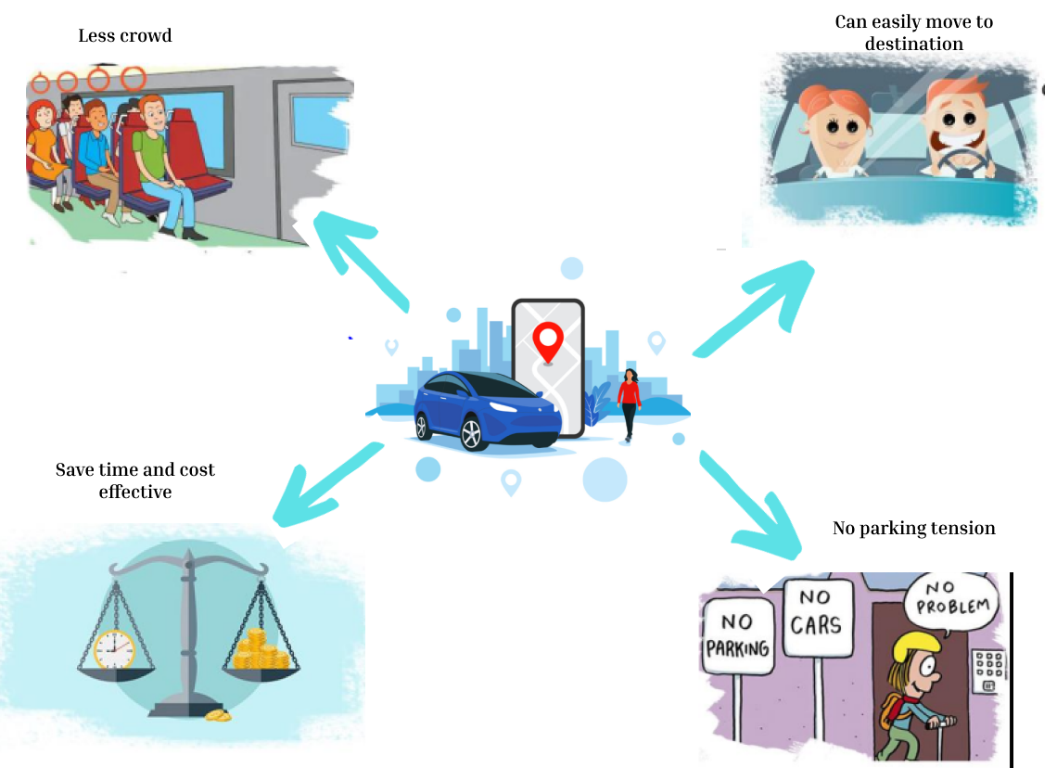

Figure 4: Problem solution

# Researched Question

The below point are research questions;

* How can various GIS technologies be researched and implemented to enhance usability in Ride sharing application?
* What are the different implementation strategies that can be adopted in Ride sharing service to enhance effective implementation of GIS technologies?
* What are the areas of integration of GIS in ride sharing app?
* What are the feasible development pathways that ride sharing service can follow for the implementation of GIS?
* What is the complexity in designing database, system design and data flow that are affecting the implementation of GIS in Ridesharing

# Literature Review

# Secondary Research

**Pathao**

Pathao was originally formed in Dhaka, Bangladesh. The word ‘Pathao’ represents the same meaning ‘Send’ in both Bengali & Nepali. Previously a delivery company, it turned into a ride-sharing platform in 2016. In September 2018, [Pathao](https://pathao.com/np/)started its service in Nepal. The company commenced its bike services on 24 September 2018, car services on 9 August 2019. Also, it started delivering food on 2 October 2020.

**Tootle**

Tootle is the only ride-sharing service, originally formed in Nepal in 2017. Also, it is the initiator of ride-sharing services in Nepal. It excited people for using bike services which are very cheaper than regular taxis. One just simply has to turn GPS on, open the app & book the ride from their prior location to their destinations. [Tootle](https://tootle.today/)soon became one of the most promising startups of 2017. After the Covid lockdown, the bikers in Tootle got the 100% of what passengers paid for the ride.

App Performance

On Pathao, ride-booking is easy & generally takes some time as per your location. Also, one can see the rider’s icon moving around if they are available nearby. This makes it handy to know about the availability. Invite & Earn feature is also there where one can refer Pathao to a friend and in return get discount vouchers on rides & food. The app is stable. One thing to mention, Pathao sends a ton of notifications here and there regarding, food vouchers, movies launch, etc. This might not be a convincing thing for all.

On Tootle, Ride booking is also easy and similar to Pathao. While sometimes, the app might crash during canceling a ride. The stability of the app is affected by crashes here and then. Tootle used to be a popular medium a few years ago when it was the first and only ride-sharing app. When it comes to the availability of riders, it depends on the core location of the city. It usually takes a longer time than Pathao to find the rider in less populated areas. However, Tootle doesn’t send annoying notifications, unlike Pathao.

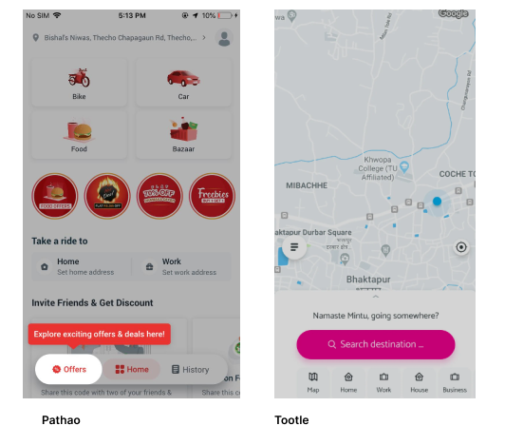

# Development Methodology

## Waterfall

The waterfall is a sequential model example. The software development process in this model is subdivided into different stages and every step consists of a number of tasks an aim. It is necessary to complete a phase before the beginning of the next stage. The output of one step is sequentially the source for the next process. So, any development phase only starts when the previous stage is completed. The waterfall model is a sequential process in which progress is perceived in phases of development, initiation, evaluation, testing, implementation and maintenance as flowing continuously downwards like waterfall.

**Why Waterfall?**

In my project I have used waterfall model because it there are lots of benefits of using these models.

* It is suitable for smaller projects with very good understanding of specifications.
* The stages are clearly divided, so that every task can be conveniently organized.
* The requirements are very clear and easy to understand.
* Waterfall model is easy to handle because of the rigidity of the model, it is easy and simple to understand.
* Well understood milestones.

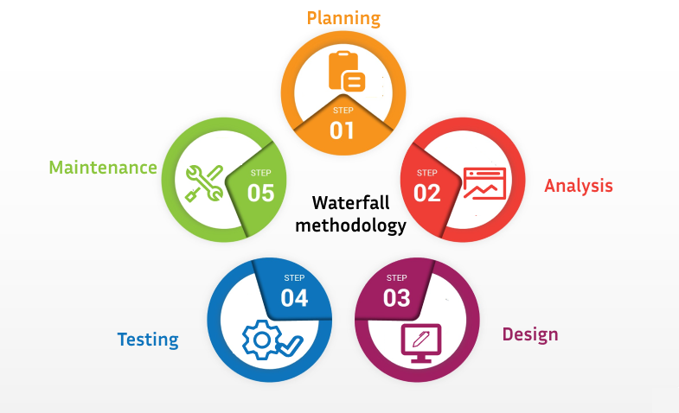

Figure 5: Stages in waterfall methodology

# Tools



**Android Studio**

It is the official Integrated Development Environment (IDE) designed specifically for Android development. Android is one of the Operating system of Google and is one of the most installed OS on mobile phones. Android Studio is developed by JetBrains and Google. Android Studio is supported on many platforms like windows, MacOS and Linux based operating system.

# Technology

**Flutter**

Flutter is Google's portable UI toolkit for crafting beautiful, natively compiled applications for mobile, web, and desktop from a single codebase. Flutter works with existing code, is used by developers and organizations around the world, and is free and open source.

**Firebase**

Firebase is a platform where web and mobile apps can be built without the language of programming on the server side. It gives the tool to develop high quality software and grow base for user. We can store and retrieve user data from your database in real time that synchronizes information between user data

**Google directions API**

This API enables you to calculate directions between locations using Google. In my project this API helps user to find the route to the destination from their current location. It also helps to determine how far the device is from the actual location.

**Google Maps API**

Google map is developed by Google that offers mapping service. It offers API that can be implemented on different third-party devices like android, IOS and web application. Google maps provides detailed information of each geographical regions around the world. The Google Maps API add maps to your Android application based on Google Maps.

# Integration

The tools and technology used is the comprehensive part of the project. In this project different technology like Google Maps API, Google Direction API, Google Place Autocomplete API, were integrated with Android Studio to develop android mobile application. All those data are synchronized and manipulated in real-time database (firebase). The code written in Java has followed MVC framework which enhance the maintainability of the system.



Figure 6: Integrations of tools and technology

# Risk Analysis

|  |  |  |  |  |  |
| --- | --- | --- | --- | --- | --- |
| **S.N** | **Risk Description** | **Source of Occurrence** | **Impact** | **Priority** | **Solution** |
| 1 | Inappropriate research topic chosen | Lack of Knowledge in selecting topic for research | High | Medium | Topic according to the interest which intends to solve the focused problem was chosen. |
| 2 | Difficulty in finding related research work | Improper Research conducted in chosen topic. | High | Medium | Different research medium such as book, websites was searched and reviewed. |
| 3 | Changing Requirement throughout the project. | Analysis is not conducted with proper research and working with unrealistic requirement | High | Medium | Keep requirement that are realistic and that can be covered during the timeline of research. |
| 4 | Availability of human resources doesn’t match the project resources plan. | Analysis is not done properly on available sources. | High | Medium | The requirement are changed according to available source |

# SWOT Analysis

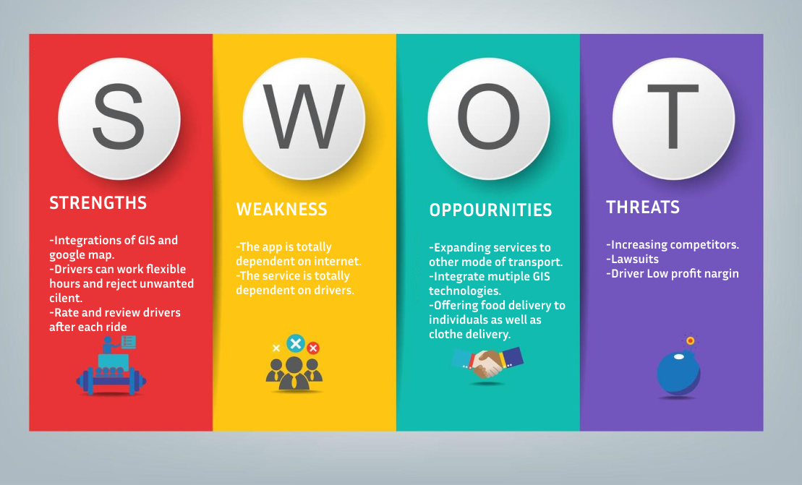

Figure 7: SWOT analysis of ridesharing app

# Conclusion

Due to the revolution in technologies and information, Ride sharing has become a popular service which is competing with different transportation modes. The real time data of traffic and transit helps to improve the usability of the system. Technology such as GPS (Global Positioning system) and mobile application have not only made the daily life easier for people but also this plays an important role in sharing economy. Ride sharing is one of the best innovations which allows passenger to use their mobile devices for arranging the way to reach their destination. In this dissertation the data collection methodology is established and the collected data based on ridesharing is used to investigate the impacts of ride sharing on today’s world. Then, efficiency of ridesharing is measured in relation to distances and times. The life before innovation of ride sharing services and life after ride sharing services is identified and those data are analyzed to find the benefits of the ride sharing. This research helped me to explore the travel behavior of people on day to day basis.

Looking the positive aspects, ride sharing helps passenger by increasing the mobility and efficiency. These services also reduce the need for parking supply. The problem in parking around the cities is one of the issues to have concern on. If each people get their personal vehicle to move around their destinations, there will definitely be lack of parking space in the city. Ride sharing also reduces traffic congestion, and emissions that vehicle produces. Talking about another positive aspects ride sharing doesn’t consider driver as the employee instead they consider them as independent contractors. The time is flexible to work on when they are free. This kind of service is also providing employment opportunities to the riders.

# Reference

Awal, M. (2021, 12 21). *techmandu*. Retrieved from techmandu: https://techmandu.com/pathao-vs-tootle/

Hoory, L. (2022, 3 25). *Forbes Advisor*. Retrieved from Forbes Advisor: https://www.forbes.com/advisor/business/what-is-waterfall-methodology/

nd. (2022, 1 22). *Java Point*. Retrieved from Java Point: https://www.javatpoint.com/android-studio

Peterdy, K. (2022, 7 30). *corporatefinanceinstitute*. Retrieved from corporatefinanceinstitute: https://corporatefinanceinstitute.com/resources/knowledge/strategy/swot-analysis/